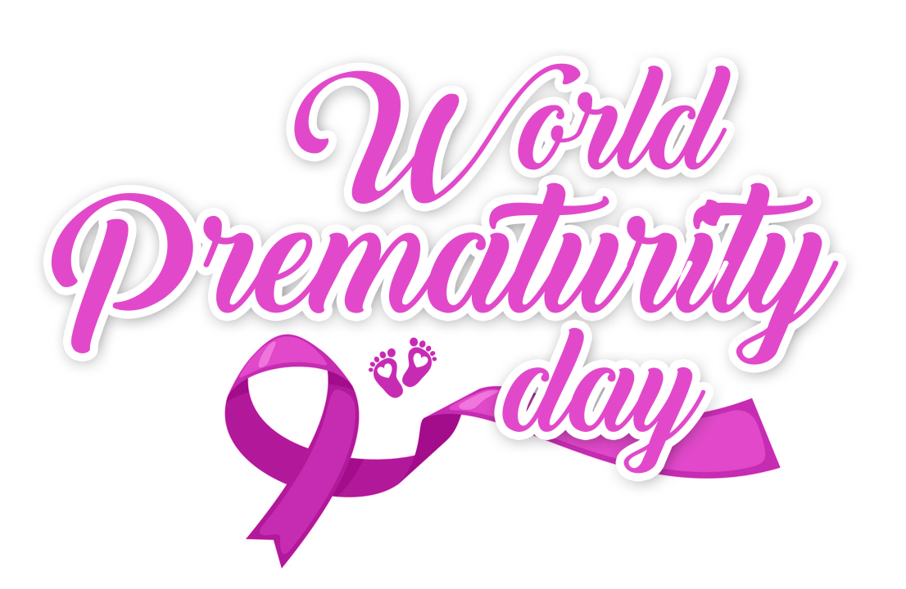

2019 World Prematurity Day
In celebration of this wonderful, World-Wide event, the Neonatal Intensive Care Department's, the Medical and Nursing Team members have prepared three (3) separate events and activities for both healthcare workers and families.

- 2019 Preemie Night Presentation
14 November 2019, 6:00PM – 8:00PM
Will be attended by NICU Gradates and their families.

- 2019 World Prematurity Day – Scientific Forum
17 November 2019, 9:00AM – 12:30PM
The program is accredited with CME hours. Onsite registration only.

- 2019 World Prematurity Day – Mini Marathon
23 November 2019, 06:30 AM – 10:00AM
All NGHA employees and their dependents are welcome to join.
To Register, go to https://www.surveymonkey.com/r/2019WPMarathon
Registration Deadline: 18 November 2019

For any inquiries, you may email nic-kasch@ngha.med.sa

